vv

# List of unsolved problems in philosophy

From Wikipedia, the free encyclopedia

|  |  |
| --- | --- |
| http://upload.wikimedia.org/wikipedia/en/thumb/9/99/Question_book-new.svg/50px-Question_book-new.svg.png | This article **needs additional citations for verification**. Please help [improve this article](http://en.wikipedia.org/w/index.php?title=List_of_unsolved_problems_in_philosophy&action=edit) by [adding citations to reliable sources](http://en.wikipedia.org/wiki/Help:Introduction_to_referencing/1). Unsourced material may be [challenged](http://en.wikipedia.org/wiki/Template:Citation_needed) and [removed](http://en.wikipedia.org/wiki/Wikipedia:Verifiability#Burden_of_evidence). *(June 2011)* |

|  |
| --- |
| [**Philosophy**](http://en.wikipedia.org/wiki/Philosophy) |
| [Left to right: Plato, Confucius, Avicenna](http://en.wikipedia.org/wiki/File:Plato,_Confucius,_Avicenna.png) |
| [**Philosophers**](http://en.wikipedia.org/wiki/Category:Philosophers) |
| * [Aestheticians](http://en.wikipedia.org/wiki/List_of_aestheticians)      * [Epistemologists](http://en.wikipedia.org/wiki/List_of_epistemologists) * [Ethicists](http://en.wikipedia.org/wiki/List_of_ethicists)      * [Logicians](http://en.wikipedia.org/wiki/List_of_logicians) * [Metaphysicians](http://en.wikipedia.org/wiki/List_of_metaphysicians) * [Social and political philosophers](http://en.wikipedia.org/wiki/List_of_social_and_political_philosophers) |
| [**Traditions**](http://en.wikipedia.org/wiki/Category:Philosophical_traditions) |
| * [Analytic](http://en.wikipedia.org/wiki/Analytic_philosophy)      * [Continental](http://en.wikipedia.org/wiki/Continental_philosophy)      * [Eastern](http://en.wikipedia.org/wiki/Eastern_philosophy) * [Islamic](http://en.wikipedia.org/wiki/Islamic_philosophy)      * [Platonic](http://en.wikipedia.org/wiki/Platonism)      * [Scholastic](http://en.wikipedia.org/wiki/Scholasticism) |
| [**Periods**](http://en.wikipedia.org/wiki/Category:Philosophy_by_period) |
| * [Ancient](http://en.wikipedia.org/wiki/Ancient_philosophy)      * [Medieval](http://en.wikipedia.org/wiki/Medieval_philosophy) * [Modern](http://en.wikipedia.org/wiki/Modern_philosophy)      * [Contemporary](http://en.wikipedia.org/wiki/Contemporary_philosophy) |
| [**Literature**](http://en.wikipedia.org/wiki/Category:Philosophical_literature) |

A counterfactual is a statement that follows this form: "If [Joseph Swan](http://en.wikipedia.org/wiki/Joseph_Swan) had not invented the modern [incandescent light bulb](http://en.wikipedia.org/wiki/Incandescent_light_bulb), then someone else would have invented it anyway." People use counterfactuals every day; however, its analysis is not so clear. Swan, after all, did invent the modern incandescent light bulb, so how can the statement be true, if it is impossible to examine its correspondence to reality? (See [correspondence theory of truth](http://en.wikipedia.org/wiki/Correspondence_theory_of_truth).) Similar statements have the form, "If you don't eat your meat, then you can't have any pudding." This is another clear if-then statement, which is not verifiable (assuming the addressee did eat his/her meat). Two proposed analyses have resulted from this question. First, some philosophers assert that background information is assumed when stating and interpreting counterfactual conditionals. In the case of the Swan statement, certain trends in the history of technology, the utility of artificial light, and the discovery of electricity may all provide evidence for a logically sound argument. However, other philosophers assert that a modal "[possible world](http://en.wikipedia.org/wiki/Possible_world)" theory offers a more accurate description of counterfactual conditionals. According to this analysis, in the Swan example one would consider the closest possible world to the real world in which [Swan did not create the modern incandescent light bulb](http://en.wikipedia.org/wiki/Incandescent_light_bulb#History_of_the_light_bulb). When a counterfactual is used as an argument to justify an illegal act, it is known as the *dirty hands argument*. For example, "if I didn't sell him drugs then someone else would have, and those drugs might not have been [cut](http://en.wikipedia.org/wiki/Cutting_agent) or more harmful."

### Material implication [[edit](http://en.wikipedia.org/w/index.php?title=List_of_unsolved_problems_in_philosophy&action=edit&section=19)]

*Main article:*[*Material conditional*](http://en.wikipedia.org/wiki/Material_conditional)

People have a pretty clear idea what if-then means. However, in [formal logic](http://en.wikipedia.org/wiki/Formal_logic), if-then is defined by material implication, which is not consistent with the common understanding of conditionals. In formal logic, the statement "If today is Saturday, then 1+1=2" is true. However, '1+1=2' is true regardless of the content of the antecedent; a causal or meaningful relation is not required. The statement as a whole must be true, because 1+1=2 cannot be false. (If it could, then on a given Saturday, so could the statement). Formal logic has shown itself extremely useful in formalizing argumentation, philosophical reasoning, and mathematics. However, the discrepancy between material implication and the general conception of conditionals is a topic of intense investigation: whether it is an inadequacy in formal logic, an ambiguity of ordinary [language](http://en.wikipedia.org/wiki/Language), or as championed by [H.P. Grice](http://en.wikipedia.org/wiki/Paul_Grice), that there is no discrepancy.

## Philosophy of mind [[edit](http://en.wikipedia.org/w/index.php?title=List_of_unsolved_problems_in_philosophy&action=edit&section=20)]

### Mind-body problem [[edit](http://en.wikipedia.org/w/index.php?title=List_of_unsolved_problems_in_philosophy&action=edit&section=21)]

The [mind-body problem](http://en.wikipedia.org/wiki/Mind-body_problem) is the problem of determining the relationship between the human body and the human mind. Philosophical positions on this question are generally predicated on either a reduction of one to the other, or a belief in the discrete coexistence of both. This problem is usually exemplified by Descartes, who championed a dualistic picture. The problem therein is to establish how the mind and body communicate in a [dualistic](http://en.wikipedia.org/wiki/Dualism) framework. [Neurobiology](http://en.wikipedia.org/wiki/Neurobiology) and [emergence](http://en.wikipedia.org/wiki/Emergence) have further complicated the problem by allowing the material functions of the mind to be a representation of some further aspect emerging from the mechanistic properties of the brain. The brain essentially stops generating conscious thought during deep sleep; the ability to restore such a pattern remains a mystery to science and is a subject of current research. (See also[neurophilosophy](http://en.wikipedia.org/wiki/Neurophilosophy)).

### Cognition and AI [[edit](http://en.wikipedia.org/w/index.php?title=List_of_unsolved_problems_in_philosophy&action=edit&section=22)]

This problem actually defines a field, however its pursuits are specific and easily stated. Firstly, what are the criteria for [intelligence](http://en.wikipedia.org/wiki/Intelligence)? What are the necessary components for defining [consciousness](http://en.wikipedia.org/wiki/Consciousness)? Secondly, how can an outside observer test for these criteria? The "[Turing Test](http://en.wikipedia.org/wiki/Turing_Test)" is often cited as a prototypical test of consciousness, although it is almost universally regarded as insufficient. It involves a series of questions, by which a sentient entity can theoretically provide answers where a machine could not. A well trained machine, however, could theoretically "parrot" its way through the test. This raises the corollary question of whether it is possible to [artificially create consciousness](http://en.wikipedia.org/wiki/Artificial_intelligence)(usually in the context of [computers](http://en.wikipedia.org/wiki/Computer) or [machines](http://en.wikipedia.org/wiki/Machine)), and of how to tell a well trained mimic from a sentient entity.

Important thought in this area includes most notably: [John Searle](http://en.wikipedia.org/wiki/John_Searle)'s [Chinese Room](http://en.wikipedia.org/wiki/Chinese_room), [Hubert Dreyfus](http://en.wikipedia.org/wiki/Hubert_Dreyfus)' non-cognitivist critique, as well as [Hilary Putnam](http://en.wikipedia.org/wiki/Hilary_Putnam)'s work on [Functionalism](http://en.wikipedia.org/wiki/Functionalism_(philosophy_of_mind)).

A related field is the [ethics of artificial intelligence](http://en.wikipedia.org/wiki/Ethics_of_artificial_intelligence), which addresses such problems as the existence of moral personhood of AIs, the possibility of moral obligations *to* AIs (for instance, the right of a possibly sentient computer system to not be turned off), and the question of making AIs that behave ethically towards humans and others.

### Hard problem of consciousness [[edit](http://en.wikipedia.org/w/index.php?title=List_of_unsolved_problems_in_philosophy&action=edit&section=23)]

The [hard problem of consciousness](http://en.wikipedia.org/wiki/Hard_problem_of_consciousness) is the question of what consciousness is and why we have consciousness as opposed to being [philosophical zombies](http://en.wikipedia.org/wiki/Philosophical_zombies). The adjective "hard" is to contrast with the "easy" consciousness problems, which seek to explain the mechanisms of consciousness ("why" versus "how," or [final cause](http://en.wikipedia.org/wiki/Final_cause) versus [efficient cause](http://en.wikipedia.org/wiki/Efficient_cause)). The hard problem of consciousness is questioning whether all beings undergo an experience of consciousness rather than questioning the neurological makeup of beings.

## Philosophy of science [[edit](http://en.wikipedia.org/w/index.php?title=List_of_unsolved_problems_in_philosophy&action=edit&section=24)]

### Problem of induction [[edit](http://en.wikipedia.org/w/index.php?title=List_of_unsolved_problems_in_philosophy&action=edit&section=25)]

*Main article:*[*Problem of induction*](http://en.wikipedia.org/wiki/Problem_of_induction)

Intuitively, it seems to be the case that we know certain things with absolute, complete, utter, unshakable certainty. For example, if you travel to the Arctic and touch an iceberg, you know that it would feel cold. These things that we know from experience are known through induction. The problem of induction in short; (1) any inductive statement (like the sun will rise tomorrow) can only be deductively shown if one assumes that nature is uniform. (2) the only way to show that nature is uniform is by using induction. Thus induction cannot be justified deductively.

### Demarcation problem [[edit](http://en.wikipedia.org/w/index.php?title=List_of_unsolved_problems_in_philosophy&action=edit&section=26)]

*Main article:*[*Demarcation problem*](http://en.wikipedia.org/wiki/Demarcation_problem)

‘The problem of demarcation’ is an expression introduced by [Karl Popper](http://en.wikipedia.org/wiki/Karl_Popper) to refer to ‘the problem of finding a criterion which would enable us to distinguish between the empirical sciences on the one hand, and mathematics and logic as well as "metaphysical" systems on the other’. Popper attributes this problem to [Kant](http://en.wikipedia.org/wiki/Kant). Although Popper mentions mathematics and logic, other writers focus on distinguishing [science](http://en.wikipedia.org/wiki/Science) from [metaphysics](http://en.wikipedia.org/wiki/Metaphysics) and [pseudo-science](http://en.wikipedia.org/wiki/Pseudo-science).

Some, including Popper, raise the problem because of an intellectual desire to clarify this distinction. Logical positivists had, in addition, a social and intellectual agenda to discredit non-scientific disciplines.

### Realism [[edit](http://en.wikipedia.org/w/index.php?title=List_of_unsolved_problems_in_philosophy&action=edit&section=27)]

*Main article:*[*Scientific realism*](http://en.wikipedia.org/wiki/Scientific_realism)

Is there a world independent of human beliefs and representations? Is such a world empirically accessible, or would such a world be forever beyond the bounds of human sense and hence unknowable? Can human activity and agency change the objective structure of the world? These questions continue to receive much attention in the philosophy of science. A clear "yes" to the first question is a hallmark of the [scientific realism](http://en.wikipedia.org/wiki/Scientific_realism) perspective. Philosophers such as [Bas van Fraassen](http://en.wikipedia.org/wiki/Bas_van_Fraassen) have important and interesting answers to the second question. In addition to the realism vs. [empiricism](http://en.wikipedia.org/wiki/Empiricism) axis of debate, there is a realism vs. [social constructivism](http://en.wikipedia.org/wiki/Social_constructivism) axis which heats many academic passions. With respect to the third question, [Paul Boghossian](http://en.wikipedia.org/wiki/Paul_Boghossian)'s ["Fear of Knowledge: Against Relativism and Constructivism"](http://www.oup.com/us/catalog/general/subject/Philosophy/Epistemology/~~/dmlldz11c2EmY2k9OTc4MDE5OTI4NzE4NQ==). Oxford University Press. 2006. is a powerful critique of social constructivism, for instance. Ian Hacking's *The Social Construction of What?* (Harvard UP, 2000) constitutes a more moderate critique of constructivism, which usefully disambiguates confusing polysemy of the term "constructivism."

## See also [[edit](http://en.wikipedia.org/w/index.php?title=List_of_unsolved_problems_in_philosophy&action=edit&section=28)]

* [List of years in philosophy](http://en.wikipedia.org/wiki/List_of_years_in_philosophy)
* [Thought experiment](http://en.wikipedia.org/wiki/Thought_experiment)

## References [[edit](http://en.wikipedia.org/w/index.php?title=List_of_unsolved_problems_in_philosophy&action=edit&section=29)]

* 1. [**^**](http://en.wikipedia.org/wiki/List_of_unsolved_problems_in_philosophy#cite_ref-1) [Locke, John](http://en.wikipedia.org/wiki/John_Locke). [*An Essay Concerning Human Understanding*](http://en.wikipedia.org/wiki/An_Essay_Concerning_Human_Understanding), Book 2, Chapter 9.

"I shall here inset a problem of that very ingenious and studious promoter of real knowledge, the learned and worthy Mr. Molyneux, which he was pleased to send me in a letter some months since; and it is this:- "Suppose a man born blind, and now adult, and taught by his touch to distinguish between a cube and a sphere of the same metal, and nighly of the same bigness, so as to tell, when he felt one and the other, which is the cube, which the sphere. Suppose then the cube and sphere placed on a table, and the blind man be made to see: quaere, whether by his sight, before he touched them, he could now distinguish and tell which is the globe, which the cube?" To which the acute and judicious proposer answers, "Not. For, though he has obtained the experience of how a globe, how a cube affects his touch, yet he has not yet obtained the experience, that what affects his touch so or so, must affect his sight so or so; or that a protuberant angle in the cube, that pressed his hand unequally, shall appear to his eye as it does in the cube."- I agree with this thinking gentleman, whom I am proud to call my friend, in his answer to this problem; and am of opinion that the blind man, at first sight, would not be able with certainty to say which was the globe, which the cube, whilst he only saw them; though he could unerringly name them by his touch, and certainly distinguish them by the difference of their figures felt. This I have set down, and leave with my reader, as an occasion for him to consider how much he may be beholden to experience, improvement, and acquired notions, where he thinks he had not the least use of, or help from them. And the rather, because this observing gentleman further adds, that "having, upon the occasion of my book, proposed this to divers very ingenious men, he hardly ever met with one that at first gave the answer to it which he thinks true, till by hearing his reasons they were convinced."

* 1. [**^**](http://en.wikipedia.org/wiki/List_of_unsolved_problems_in_philosophy#cite_ref-2) Muhammad ibn Abd al-Malik [Ibn Tufayl](http://en.wikipedia.org/wiki/Ibn_Tufayl) and Léon Gauthier (1981), *Risalat Hayy ibn Yaqzan*, p. 5, Editions de la Méditerranée.

"If you want a comparison that will make you clearly grasp the difference between the [perception](http://en.wikipedia.org/wiki/Perception), such as it is understood by that sect [the Sufis] and the perception as others understand it, imagine a person born [blind](http://en.wikipedia.org/wiki/Blindness), endowed however with a happy natural [temperament](http://en.wikipedia.org/wiki/Temperament), with a lively and firm [intelligence](http://en.wikipedia.org/wiki/Intelligence), a sure [memory](http://en.wikipedia.org/wiki/Memory), a straight sprite, who grew up from the time he was an infant in a city where he never stopped learning, by means of the [senses](http://en.wikipedia.org/wiki/Sense) he did dispose of, to know the inhabitants individually, the numerous species of beings, living as well as non-living, there, the streets and sidestreets, the houses, the steps, in such a manner as to be able to cross the city without a guide, and to recognize immediately those he met; the [colors](http://en.wikipedia.org/wiki/Color) alone would not be known to him except by the names they bore, and by certain definitions that designated them. Suppose that he had arrived at this point and suddenly, his eyes were opened, he recovered his view, and he crosses the entire city, making a tour of it. He would find no object different from the idea he had made of it; he would encounter nothing he didn’t recognize, he would find the colors conformable to the descriptions of them that had been given to him; and in this there would only be two new important things for him, one the consequence of the other: a clarity, a greater [brightness](http://en.wikipedia.org/wiki/Brightness), and a great voluptuousness."

* 1. [**^**](http://en.wikipedia.org/wiki/List_of_unsolved_problems_in_philosophy#cite_ref-3) Lobel, Diana. *A Sufi-Jewish Dialogue: Philosophy and Mysticism in Baḥya Ibn Paqūda's Duties of the Heart*, [University of Pennsylvania Press](http://en.wikipedia.org/wiki/University_of_Pennsylvania_Press), 2006, p.24. [ISBN 0-8122-3953-9](http://en.wikipedia.org/wiki/Special:BookSources/0812239539)

|  |  |  |  |  |  |  |
| --- | --- | --- | --- | --- | --- | --- |
| |  |  | | --- | --- | | [[hide](http://en.wikipedia.org/wiki/List_of_unsolved_problems_in_philosophy)]   * [v](http://en.wikipedia.org/wiki/Template:Unsolved_problems)      * [t](http://en.wikipedia.org/wiki/Template_talk:Unsolved_problems)      * [e](http://en.wikipedia.org/w/index.php?title=Template:Unsolved_problems&action=edit)   [**Unsolved problems**](http://en.wikipedia.org/wiki/List_of_unsolved_problems)**by discipline** | | |  |  | | * [Biology](http://en.wikipedia.org/wiki/List_of_unsolved_problems_in_biology)      * [Chemistry](http://en.wikipedia.org/wiki/List_of_unsolved_problems_in_chemistry)      * [Computer science](http://en.wikipedia.org/wiki/List_of_unsolved_problems_in_computer_science)      * [Economics](http://en.wikipedia.org/wiki/List_of_unsolved_problems_in_economics)      * [Linguistics](http://en.wikipedia.org/wiki/List_of_unsolved_problems_in_linguistics)      * [Mathematics](http://en.wikipedia.org/wiki/List_of_unsolved_problems_in_mathematics)   + [lists](http://en.wikipedia.org/wiki/Lists_of_unsolved_problems_in_mathematics)        * [Neuroscience](http://en.wikipedia.org/wiki/List_of_unsolved_problems_in_neuroscience)      * **Philosophy**      * [Physics](http://en.wikipedia.org/wiki/List_of_unsolved_problems_in_physics)      * [Statistics](http://en.wikipedia.org/wiki/List_of_unsolved_problems_in_statistics) | | |

[Categories](http://en.wikipedia.org/wiki/Help:Categories):

* [Lists of unsolved problems](http://en.wikipedia.org/wiki/Category:Lists_of_unsolved_problems)
* [Philosophical problems](http://en.wikipedia.org/wiki/Category:Philosophical_problems)
* [Philosophy-related lists](http://en.wikipedia.org/wiki/Category:Philosophy-related_lists)

## Navigation menu

* [Create account](http://en.wikipedia.org/w/index.php?title=Special:UserLogin&returnto=List+of+unsolved+problems+in+philosophy&type=signup)
* [Log in](http://en.wikipedia.org/w/index.php?title=Special:UserLogin&returnto=List+of+unsolved+problems+in+philosophy)
* [Article](http://en.wikipedia.org/wiki/List_of_unsolved_problems_in_philosophy)
* [Talk](http://en.wikipedia.org/wiki/Talk:List_of_unsolved_problems_in_philosophy)
* [Read](http://en.wikipedia.org/wiki/List_of_unsolved_problems_in_philosophy)
* [Edit](http://en.wikipedia.org/w/index.php?title=List_of_unsolved_problems_in_philosophy&action=edit)
* [View history](http://en.wikipedia.org/w/index.php?title=List_of_unsolved_problems_in_philosophy&action=history)

Top of Form



Bottom of Form

* [Main page](http://en.wikipedia.org/wiki/Main_Page)
* [Contents](http://en.wikipedia.org/wiki/Portal:Contents)
* [Featured content](http://en.wikipedia.org/wiki/Portal:Featured_content)
* [Current events](http://en.wikipedia.org/wiki/Portal:Current_events)
* [Random article](http://en.wikipedia.org/wiki/Special:Random)
* [Donate to Wikipedia](http://donate.wikimedia.org/wiki/Special:FundraiserRedirector?utm_source=donate&utm_medium=sidebar&utm_campaign=C13_en.wikipedia.org&uselang=en)
* [Wikimedia Shop](http://shop.wikimedia.org/)

### [Interaction](http://en.wikipedia.org/wiki/List_of_unsolved_problems_in_philosophy)

* [Help](http://en.wikipedia.org/wiki/Help:Contents)
* [About Wikipedia](http://en.wikipedia.org/wiki/Wikipedia:About)
* [Community portal](http://en.wikipedia.org/wiki/Wikipedia:Community_portal)
* [Recent changes](http://en.wikipedia.org/wiki/Special:RecentChanges)
* [Contact Wikipedia](http://en.wikipedia.org/wiki/Wikipedia:Contact_us)

### [Toolbox](http://en.wikipedia.org/wiki/List_of_unsolved_problems_in_philosophy)

### [Print/export](http://en.wikipedia.org/wiki/List_of_unsolved_problems_in_philosophy)

### [Languages](http://en.wikipedia.org/wiki/List_of_unsolved_problems_in_philosophy)

* [العربية](http://ar.wikipedia.org/wiki/%D9%85%D8%B4%D9%83%D9%84%D8%A9_%D9%81%D9%84%D8%B3%D9%81%D9%8A%D8%A9)
* [Česky](http://cs.wikipedia.org/wiki/Filosofick%C3%BD_probl%C3%A9m)
* [Español](http://es.wikipedia.org/wiki/Lista_de_problemas_filos%C3%B3ficos_sin_resolver)
* [فارسی](http://fa.wikipedia.org/wiki/%D9%81%D9%87%D8%B1%D8%B3%D8%AA_%D9%85%D8%B3%D8%A6%D9%84%D9%87%E2%80%8C%D9%87%D8%A7%DB%8C_%D8%AD%D9%84%E2%80%8C%D9%86%D8%B4%D8%AF%D9%87_%D8%AF%D8%B1_%D9%81%D9%84%D8%B3%D9%81%D9%87)
* [Slovenčina](http://sk.wikipedia.org/wiki/Filozofick%C3%BD_probl%C3%A9m)
* [Edit links](http://www.wikidata.org/wiki/Q4115704#sitelinks)
* This page was last modified on 9 May 2013 at 17:12.
* Text is available under the [Creative Commons Attribution-ShareAlike License](http://en.wikipedia.org/wiki/Wikipedia:Text_of_Creative_Commons_Attribution-ShareAlike_3.0_Unported_License); additional terms may apply. By using this site, you agree to the [Terms of Use](http://wikimediafoundation.org/wiki/Terms_of_Use) and [Privacy Policy.](http://wikimediafoundation.org/wiki/Privacy_policy)   
  Wikipedia® is a registered trademark of the [Wikimedia Foundation, Inc.](http://www.wikimediafoundation.org/), a non-profit organization.
* [Privacy policy](http://wikimediafoundation.org/wiki/Privacy_policy)
* [About Wikipedia](http://en.wikipedia.org/wiki/Wikipedia:About)
* [Disclaimers](http://en.wikipedia.org/wiki/Wikipedia:General_disclaimer)
* [Contact Wikipedia](http://en.wikipedia.org/wiki/Wikipedia:Contact_us)
* [Mobile view](http://en.m.wikipedia.org/wiki/List_of_unsolved_problems_in_philosophy)
* [](http://wikimediafoundation.org/)
* [](http://www.mediawiki.org/)

iursdyoitveosyriotynsvdroitseyuveityneitvesriydeoiysvrytoievtyioesryityserityseirtyesivinytnn

vv iursdyoitveosyriotynsvdroitseyuveityneitvesriydeoiysvrytoievtyioesryityserityseirtyesivinytnn

riytsvienytpvseyrityesvirt\\\

vv iursdyoitveosyriotynsvdroitseyuveityneitvesriydeoiysvrytoievtyioesryityserityseirtyesivinytnn

riytsvienytpvseyrityesvirt\\\

riytsvienytpvseyrityesvirt\\\





sebtrsetrsetr

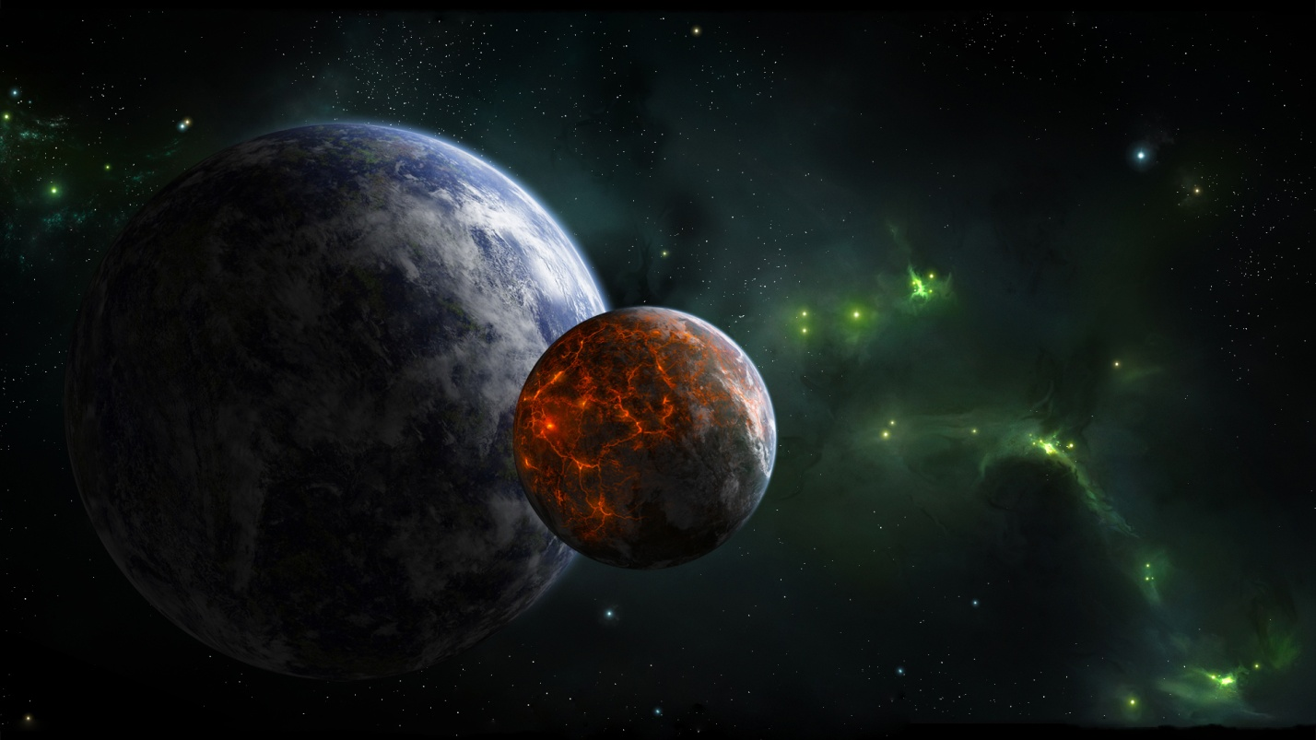



   vv  

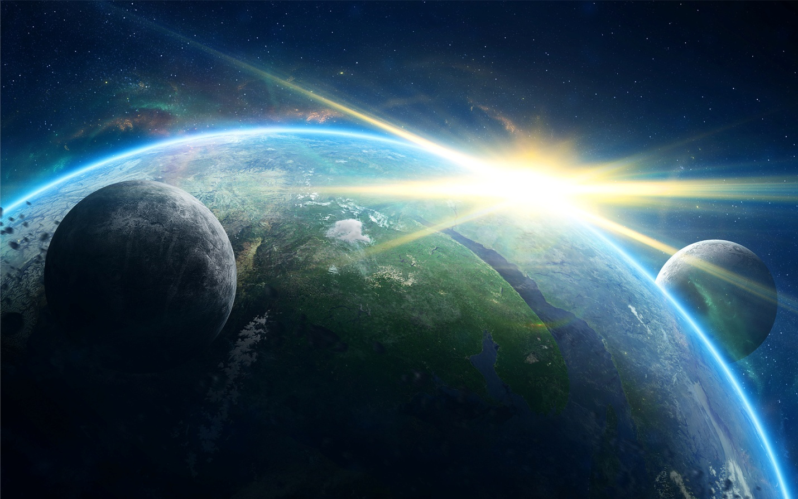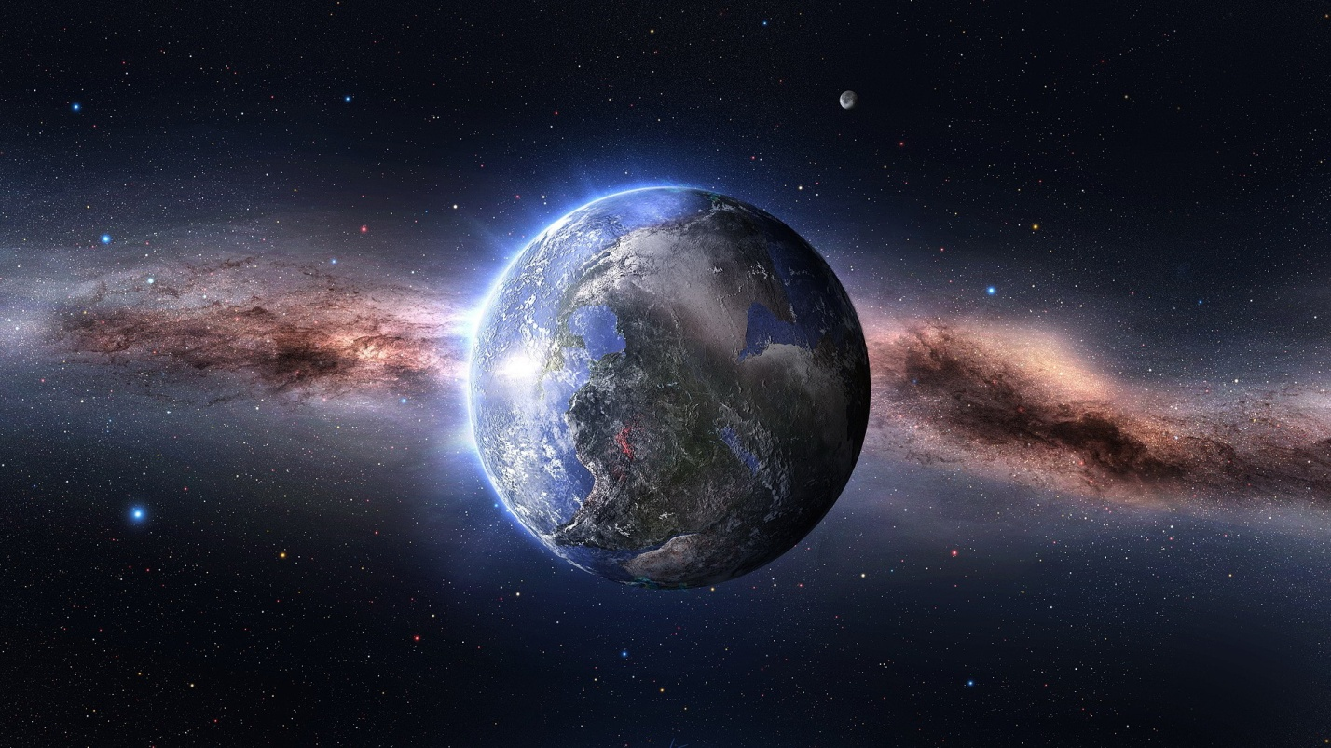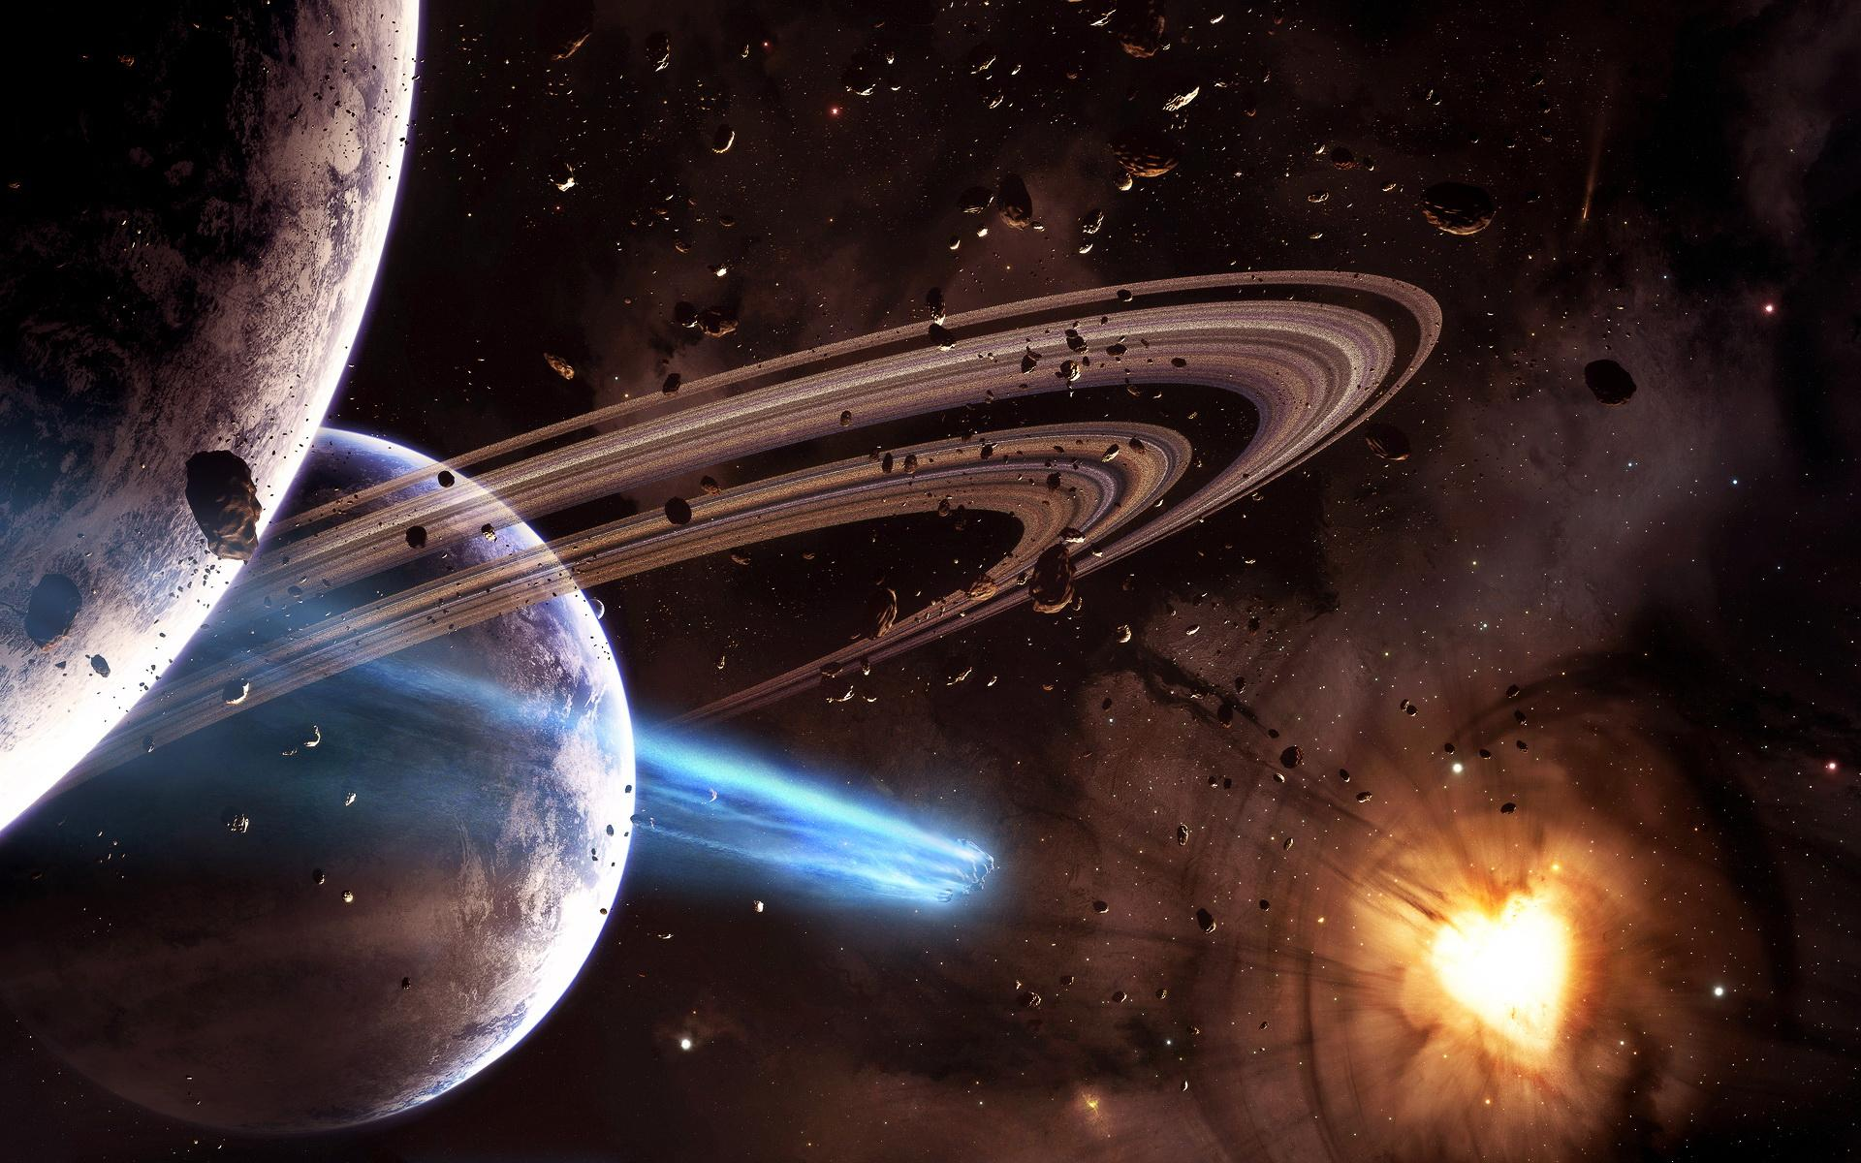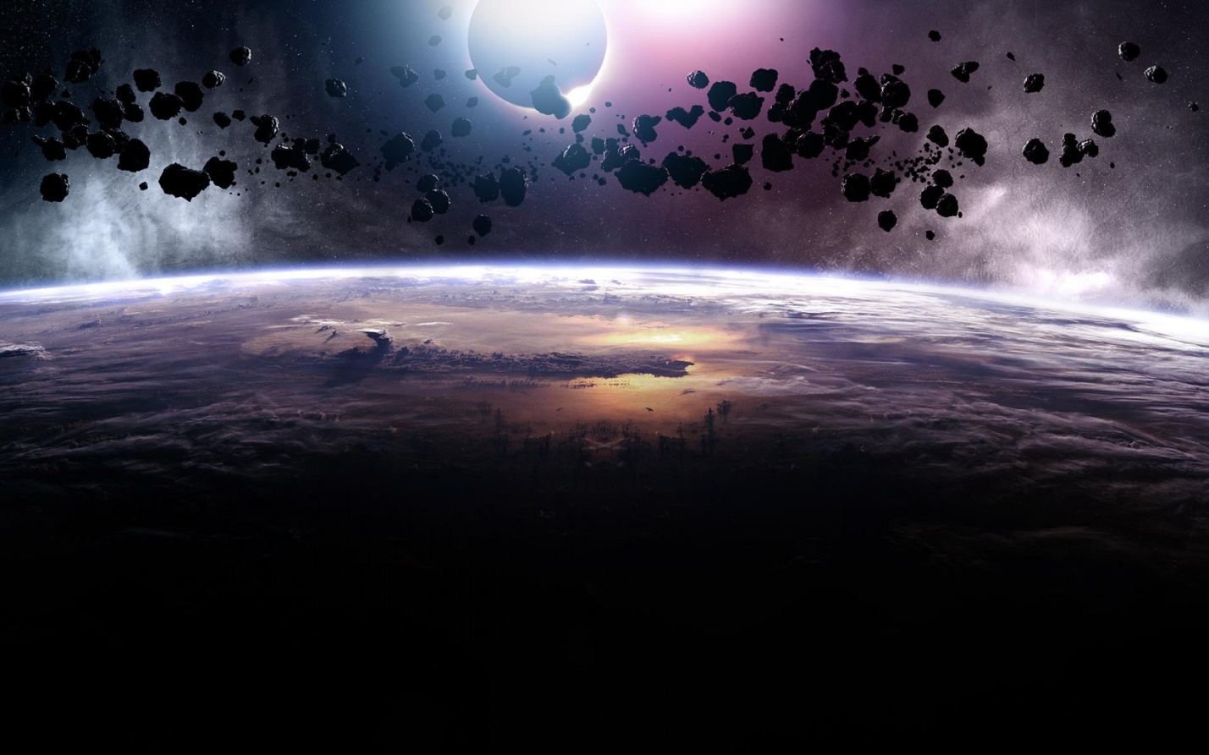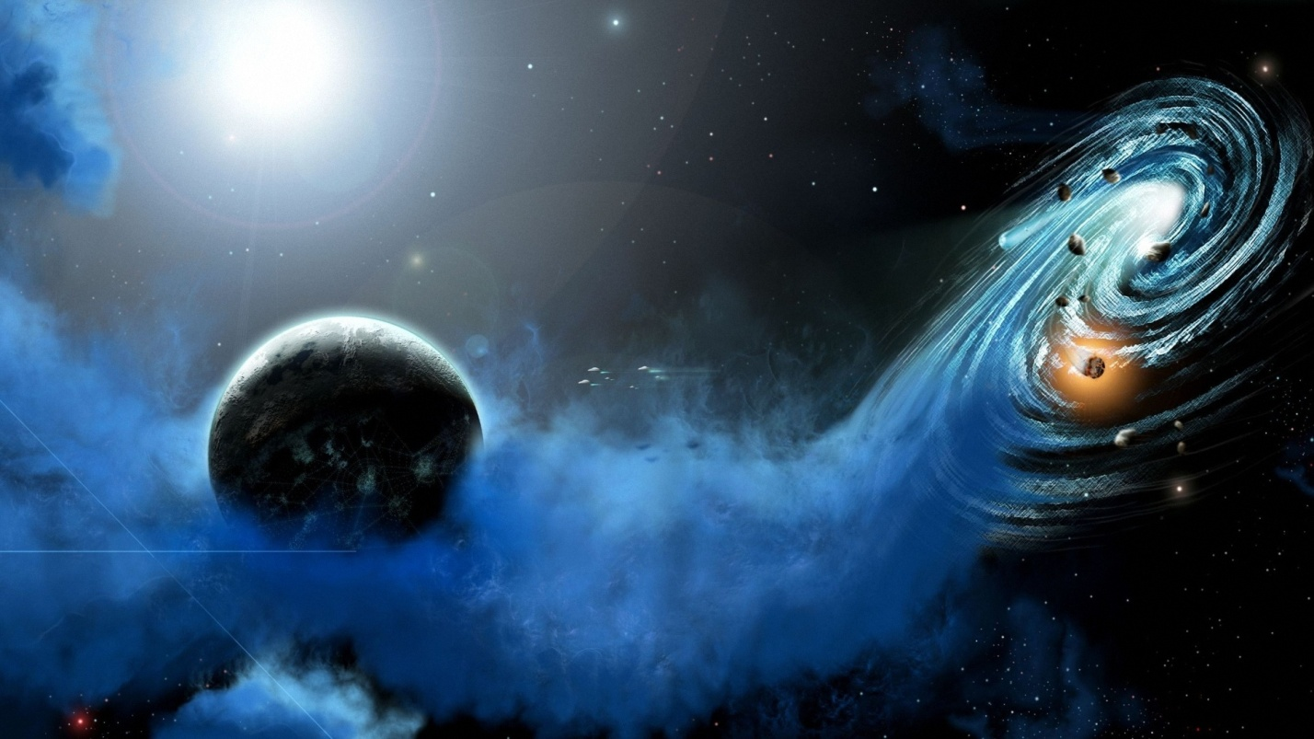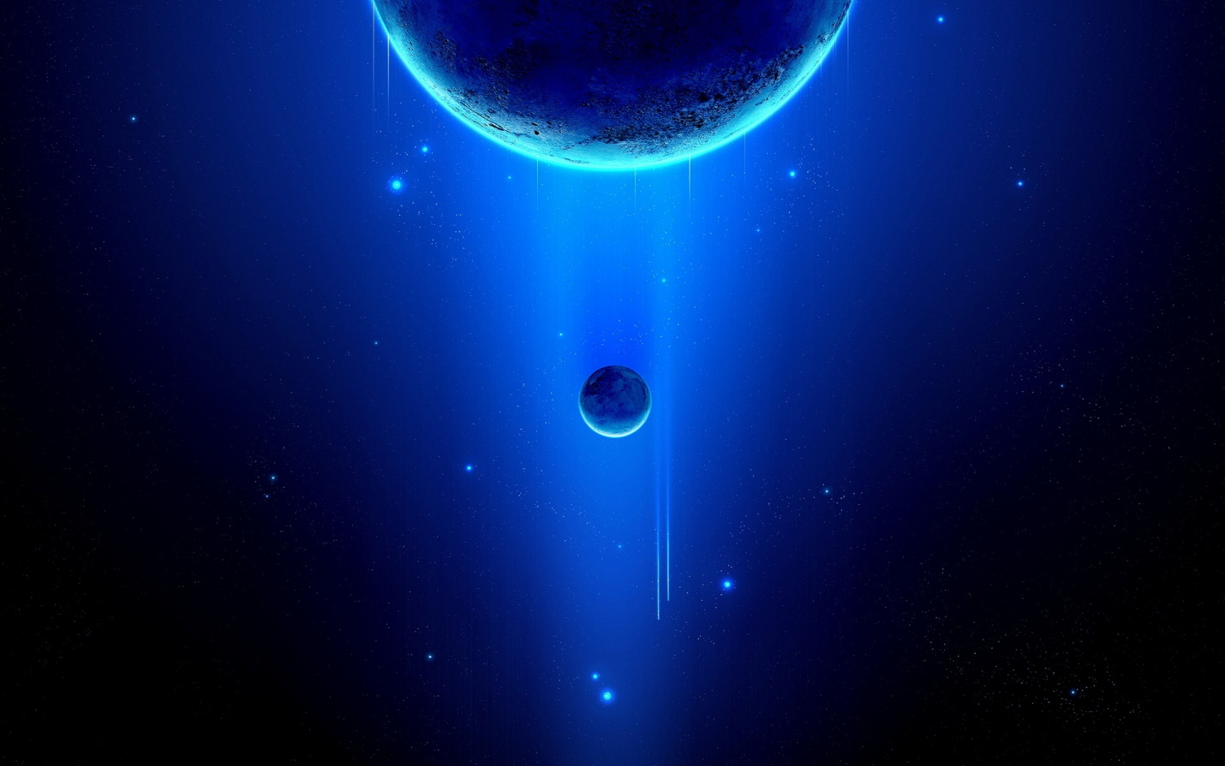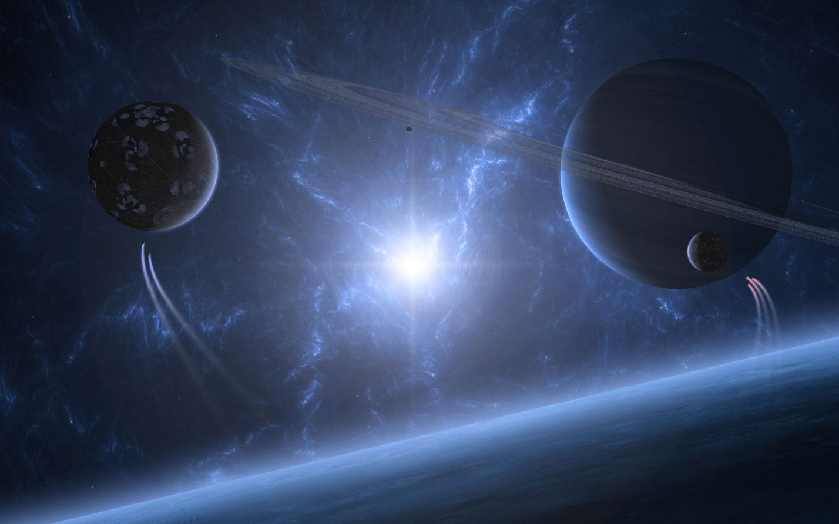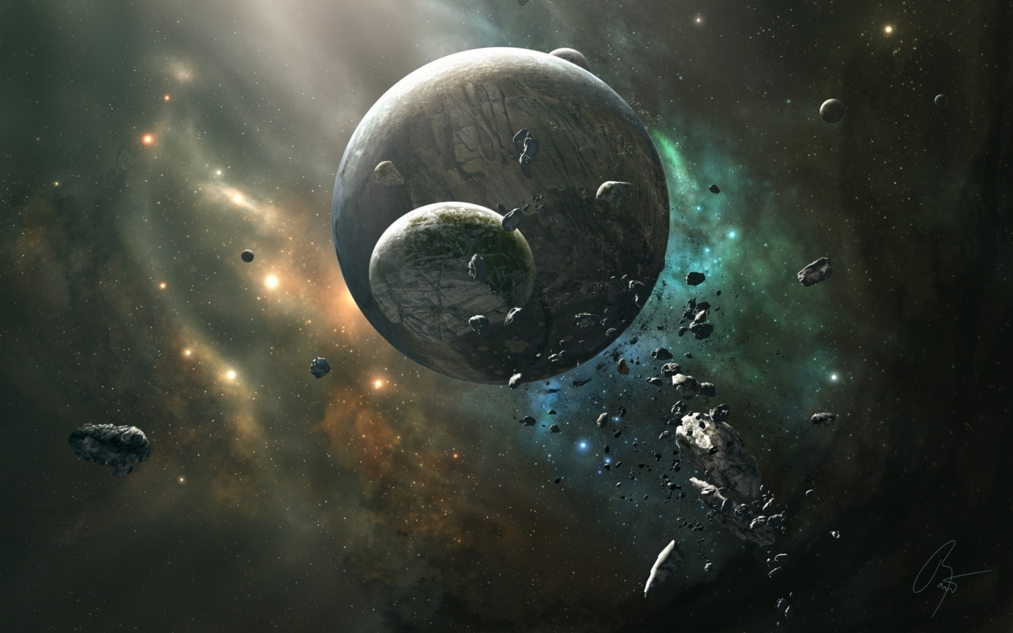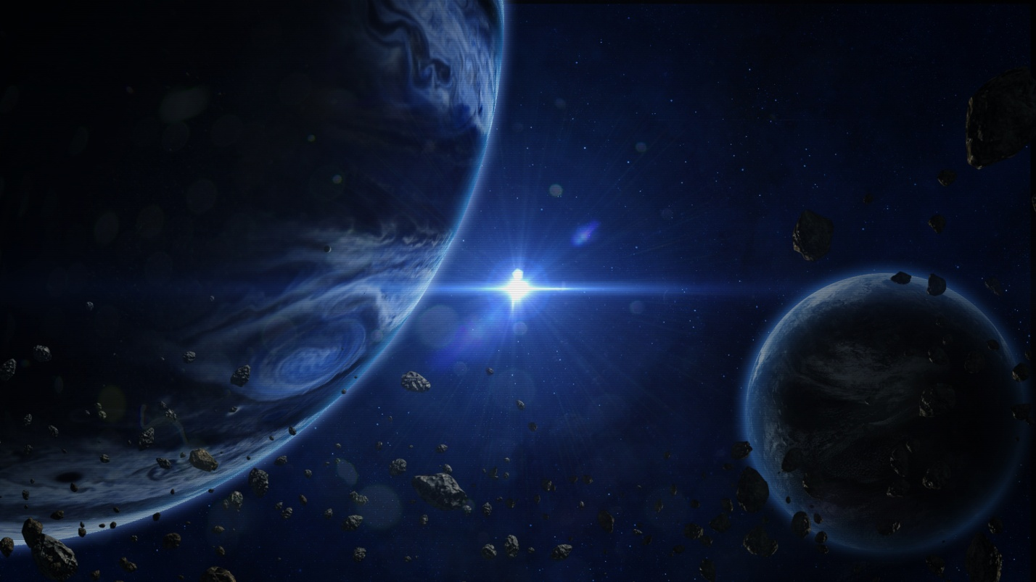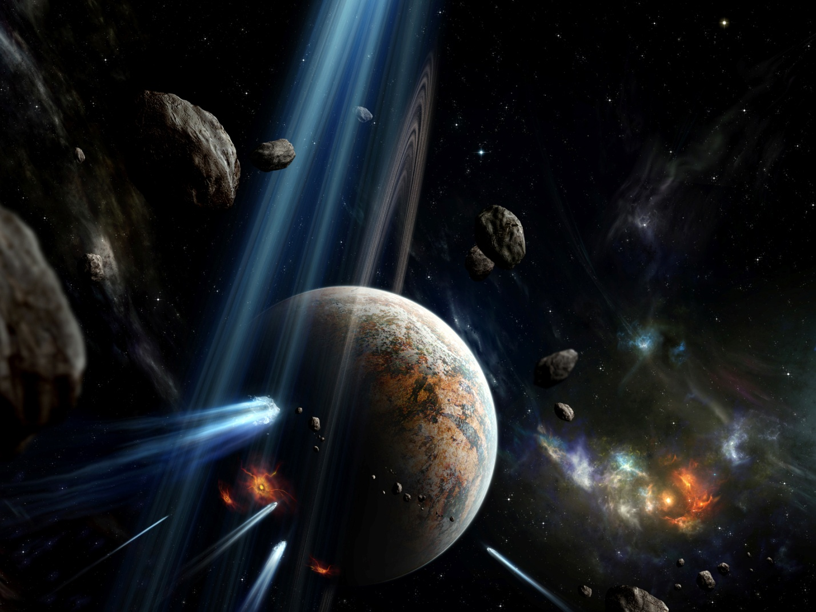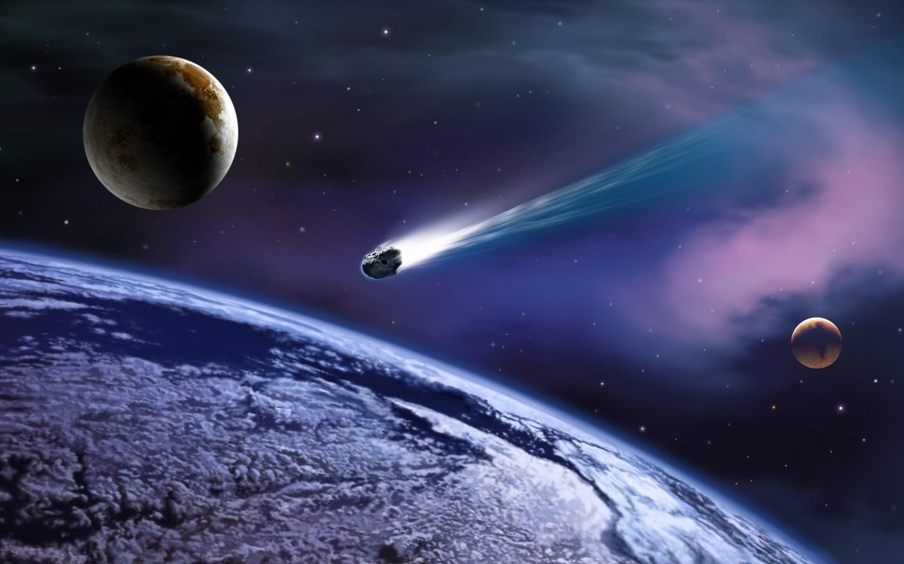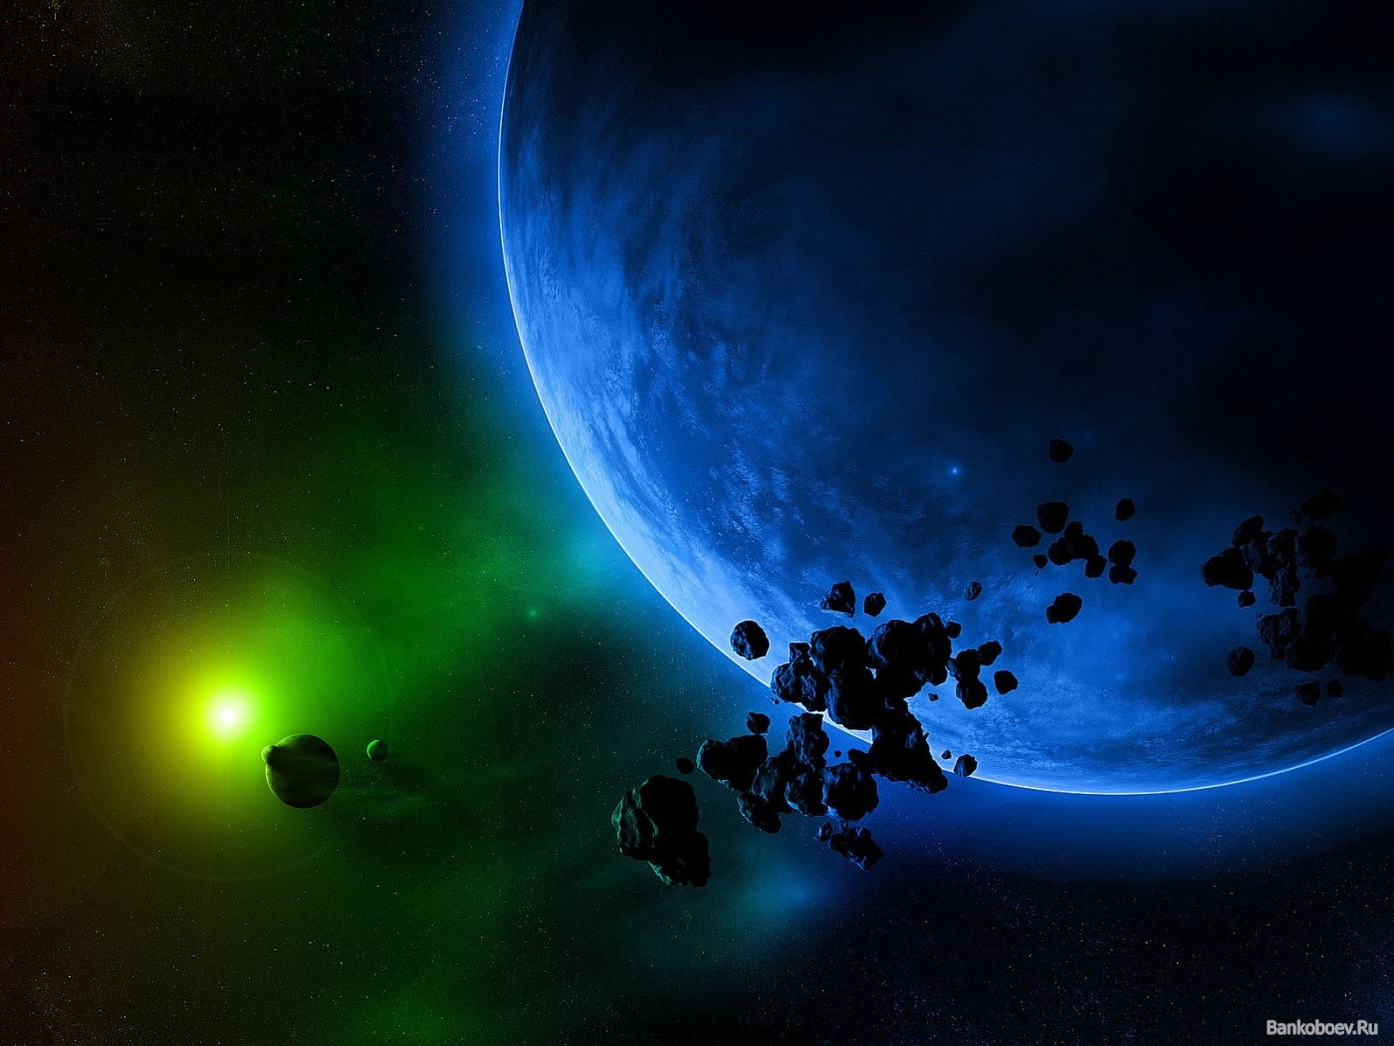

   vv  



   vv  



